

**MANAV RACHNA UNIVERSITY**

**COURSE: BTECH CSE**

**SEMESTER – 6B**

**----Agile Technologies Lab File----**

**Khushi Arora**

**CSE 6B**

**2K20CSUN01058**

**LAB FILE**

**SUBMITTED TO: Prof. (Dr.) Susmita Ray**

**Index**

|  |  |  |  |  |
| --- | --- | --- | --- | --- |
| **S.No** | **Objective** | **Lab Date** | **Submission Date** | **Teacher Signature** |
| **1** | **JDK Installation and practicing basic programs** | **11/01/23** |  |  |
|  |  |  |  |  |
|  |  |  |  |  |
|  |  |  |  |  |
|  |  |  |  |  |
|  |  |  |  |  |

**Lab 0**

**[11th January, 2023]**

Q1. Install JDK (Java Development Kit) any version 1.5 or above and verify the correctness of installation

Ans1.

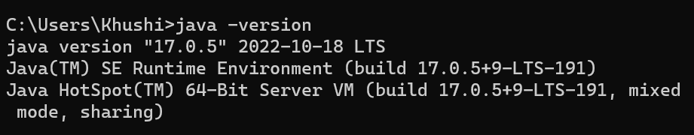

JDK was already installed in the system, therefore no need for installation.

Verified the installation by using the command:

java -version

Q2. Write the following Java programs:

(i) Write a Java program to find the minimum of a set of 10 numbers

**CODE 2(i):**

**package** Lab0;

**import** java.util.*;

**public** **class** Q2a {

**public** **static** **void** main(String[] args) {

**int** smallest = 0;

**int**[] number =**new** **int**[10];

Scanner scan = **new** Scanner(System.***in***);

**for** (**int** i = 0; i < 10; i++) {

System.***out***.print("Enter number "+i+1+" of 10: ");

number[i] = scan.nextInt();

}

System.***out***.println("Smallest: "+*getSmallest*(number,10));

scan.close();

}

**public** **static** **int** getSmallest(**int**[] a, **int** total){

**int** temp;

**for** (**int** i = 0; i < total; i++)

{

**for** (**int** j = i + 1; j < total; j++)

{

**if** (a[i] > a[j])

{

temp = a[i];

a[i] = a[j];

a[j] = temp;

}

}

}

**return** a[0];

}

}

**OUTPUT:**

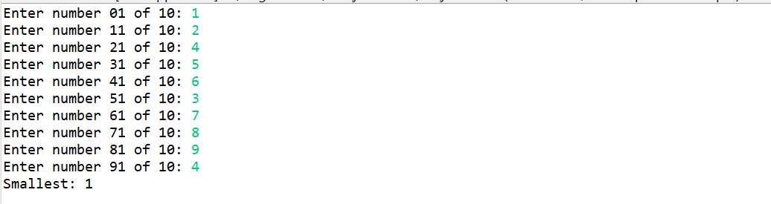

Q2. Write the following Java programs:

(ii) Write a Java program to compute the annual increment amount of employees using the following strategy:

* If monthly salary of employee is less than Rs. 1 Lakh increment should be 15 % of annual salary
* If monthly salary is in the range of Rs.1 Lakh to Rs. 2 Lakh increment should be 10% of annual salary
* If monthly salary is more than Rs. 2 Lakh increment should be 5% of annual salary

**CODE 2(ii):**

**package** Lab0;

**import** java.util.*;

**import** java.util.Scanner;

**public** **class** Q2b {

**public** **static** **void** main(String[] args) {

**int** salary = 0;

Scanner scan = **new** Scanner(System.***in***);

System.***out***.println("Enter Current Salary: ");

salary = scan.nextInt();

System.***out***.println("Incremented Salary: "+*getSalary*(salary));

scan.close();

}

**public** **static** **double** getSalary(**int** salary)

{

**double** incSalary=salary;

**if**(salary<100000)

{

incSalary=salary+(salary*0.15);

}

**else** **if**(salary>=100000 && salary<=200000)

{

incSalary=salary+(salary*0.10);

}

**else**

{

incSalary=salary+(salary*0.5);

}

**return** incSalary;

}

}

**OUTPUT:**

**Case 1: less than 1Lakh**

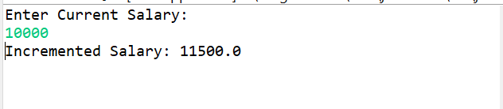

**Case 2: more than 1Lakh and less than 2Lakh**

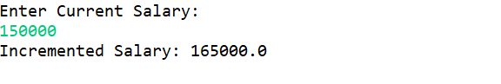

**Case 3: more than 2Lakh**

